

|  |  |  |  |  |
| --- | --- | --- | --- | --- |
| Future Program Batch 2.0 |  | Agitha Pramesti  Sembiring |  | Nadya Purbaningrum |

Software Requirements Spesification

[Sistem Point of Sale for Book Store]

Table of Contents

1. Introduction 2
2. Use Case 4
3. Flowchart 6

# Introduction

A point of sale system is a combination of software and hardware where a retail transaction is completed. Our team think that it is good for a book store having a point of sale that can manage their transaction which is include several menu such as insert books, show the detail, update book, delete book, manage the store, manage the employees, and show report for manager. This system will run on web that will used to manage all book data in the book store and make transactions. The product will be able to display all the books that are available on the bookstore and allows users to search for books according to the keywords entered into the search. The main function of the system is to manage book data, manage employees who can access the system, perform routine reports for managers, conduct transactions at the cashier.

**User characteristics**

There are only two types or roles which are available in the system, which is the role for the cashier and manager. Each of these roles has different system usage, for the cashier will be able to perform transaction processing and print receipt. The manager's role is to manage book data whether adding books, changing book data, and deleting books. Managers also play a role in managing employees or users who can access the system, manage bookstores, and get reports from the system. Each user will have a different username and password to log in which the system will then identify whether the user has the role of manager or cashier. Here is a list of the functions available to users by role :

* Cashier :

1. Manage transastion

This function allows the user to input the book to be purchased and put into the cart, make transactions or cancel the transaction, calculate the total shopping.

1. Print receipt

* Manager :

1. Manage book

This function allows to add, update, delete, display,and search for books

1. Manage employee

This function allows to add, update, display, search, and change the employee’s status such as active and non-active.

1. Manage book store

This function allows to insert data and update data for the book store.

1. View report

This function allows the manager to get the routine report such as weekly report, monthly, and yearly.

# Use Case

**Manager’s use case:**

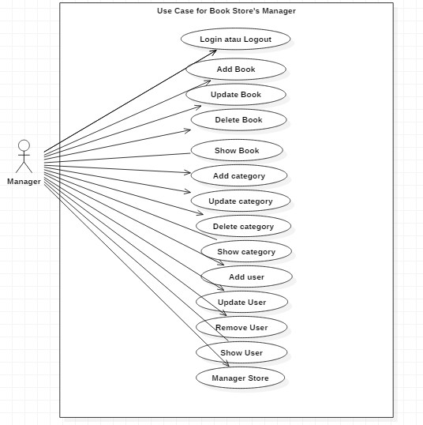

**Cashier’s use case :**

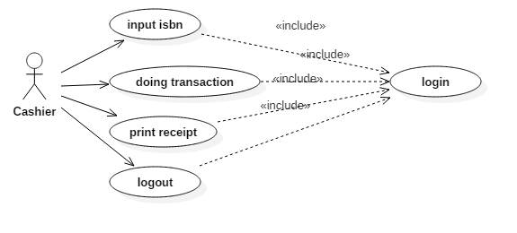

# Flowchart

**Manager :**

1. **Manager**

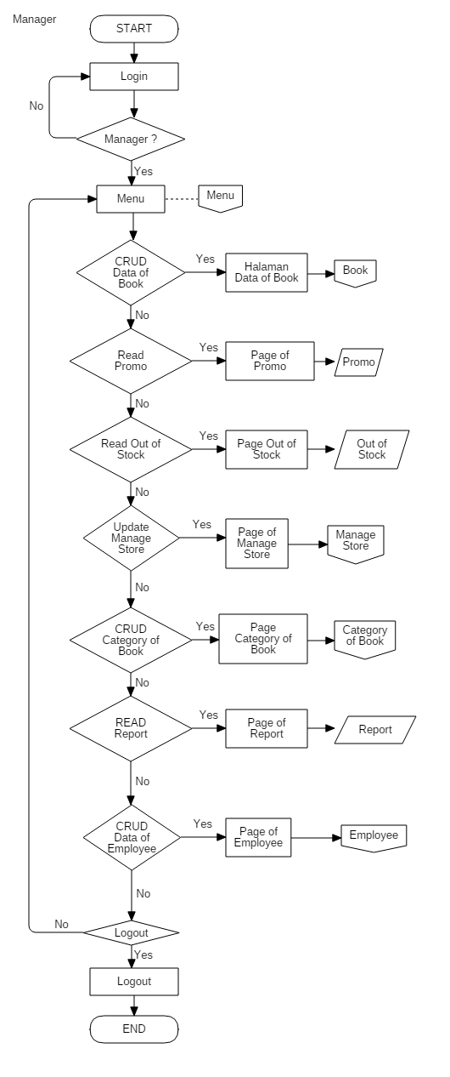

1. **Book**

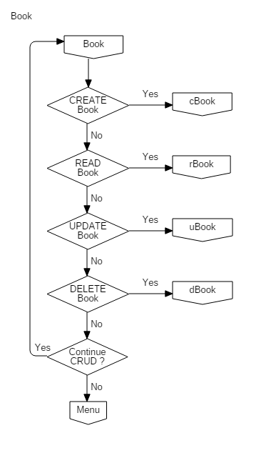

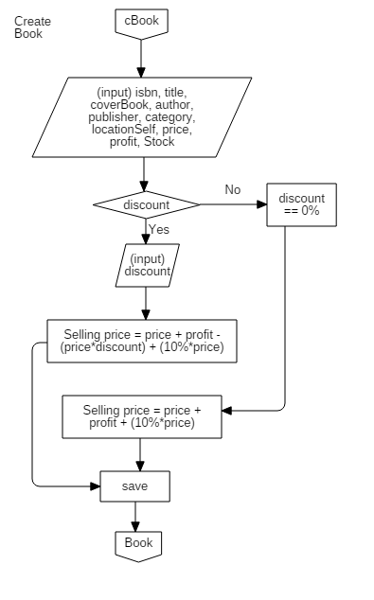

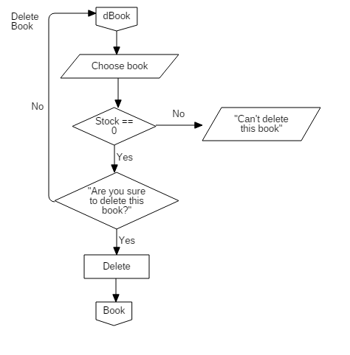

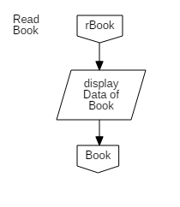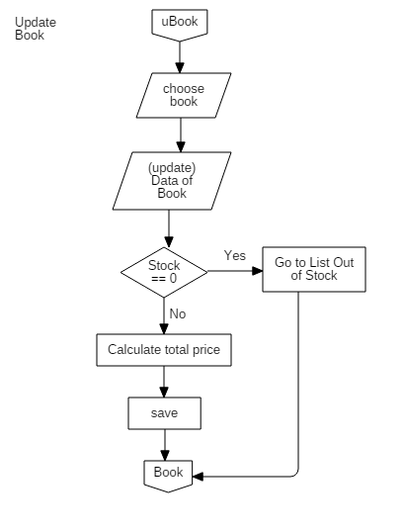

1. **Category**

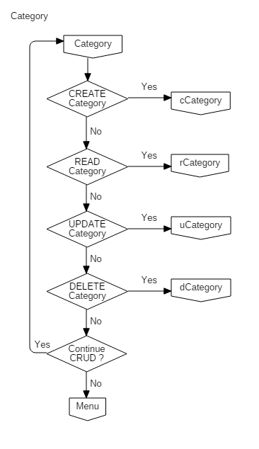

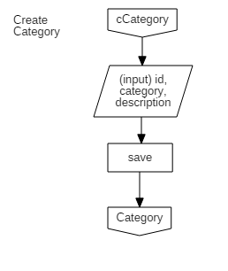

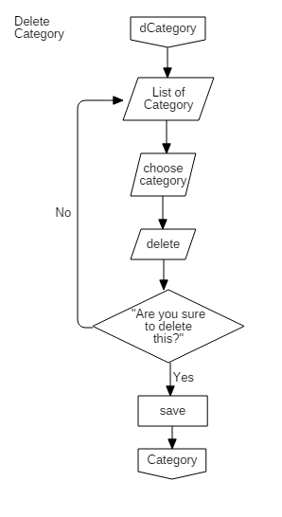

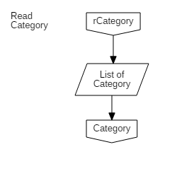

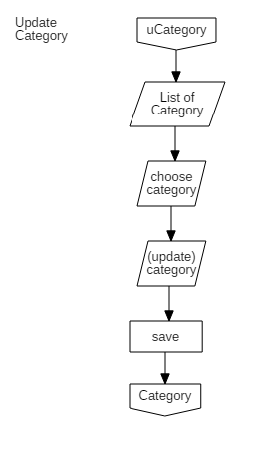

1. **Employee**

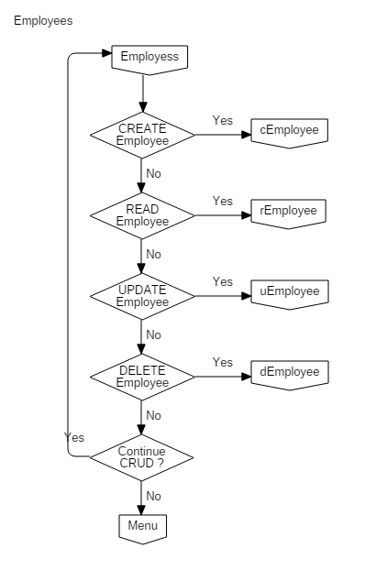

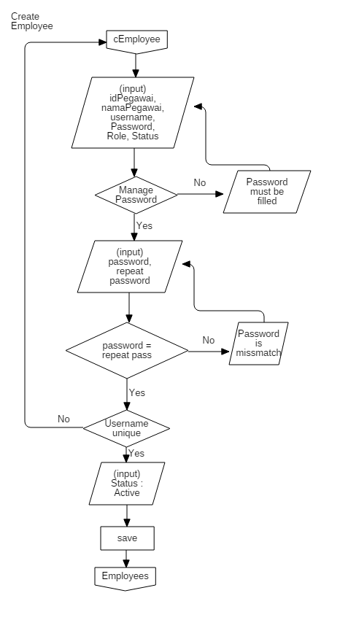

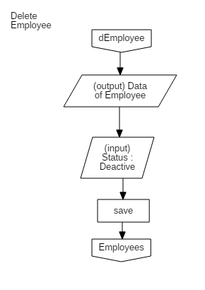

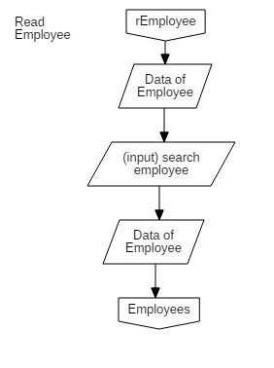

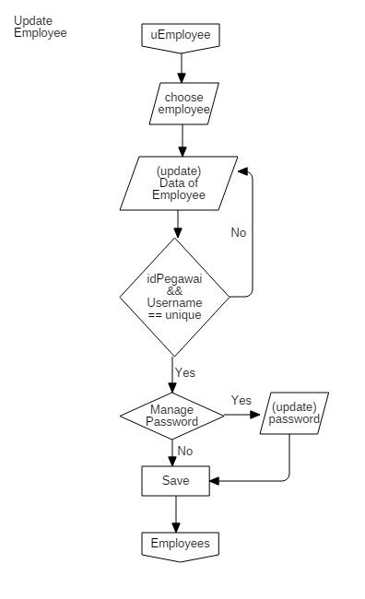

1. **Manage Store**

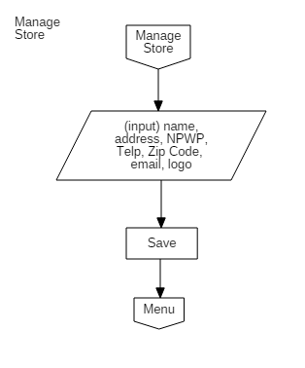

**Cashier**

